EXPERIMENT-14
Demonstrate how to work collaboratively in Git/GitHub on a project using the fork-and-pull request workflow.
Tasks:
1. Fork an existing public GitHub repository (e.g., a sample JavaScript or Python project).
2. Clone the forked repository to your local machine using Git.
3. Create a new branch for the feature or change you want to work on.
4. Make modifications or add new features (e.g., add a function, fix a bug, or update the README).
5. Commit your changes and push the branch to GitHub.
6. Go to the GitHub repository and create a pull request to merge your feature branch into the main branch.
7. Review the pull request and provide feedback on the changes.
8. Respond to feedback by making additional commits to the feature branch if necessary.
9. Once the pull request is approved, merge it into the main branch.
10. Finally submit the link to the pull request along with a summary of the changes you made and how you collaborated.
Step 1: Fork the Repository
- Open the GitHub website and sign in to your account.
- Navigate to an existing public repository.
- Click the Fork button to create a copy of the repository under your GitHub account.
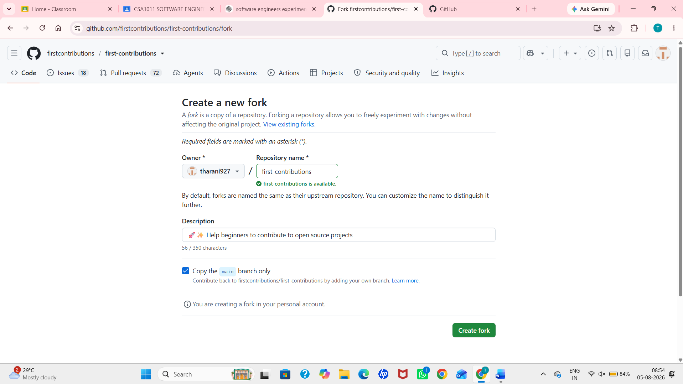
Step 2: Clone the Forked Repository
- Copy the URL of the forked repository.
- Open Git Bash or the terminal.
- Use the git clone command to clone the repository to your local machine.
- Navigate to the project directory using the cd command.
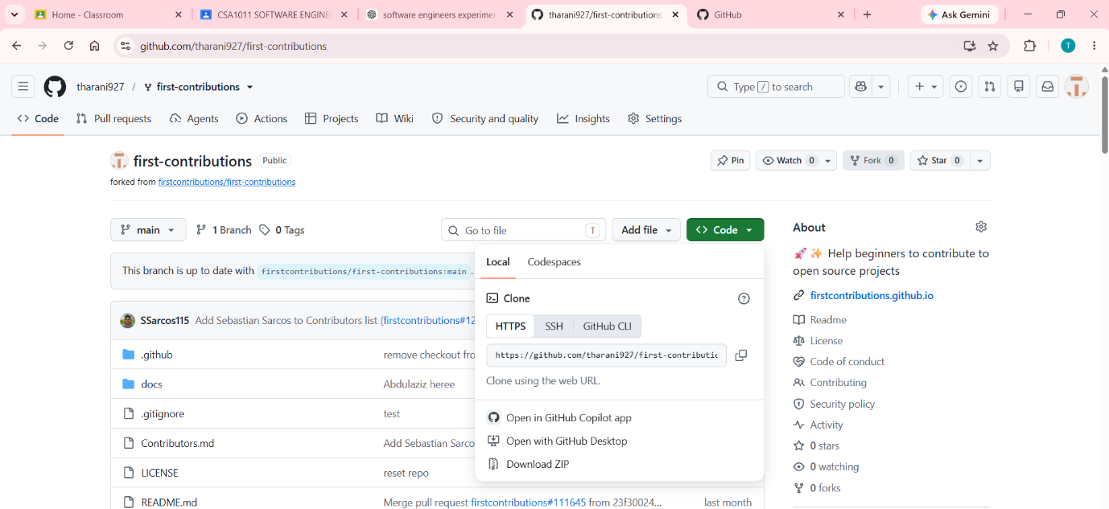

Step 3: Create a New Branch
- Create a new branch using the git checkout -b command.
- Verify that the new branch has been created successfully.
- Switch to the newly created branch before making any changes.
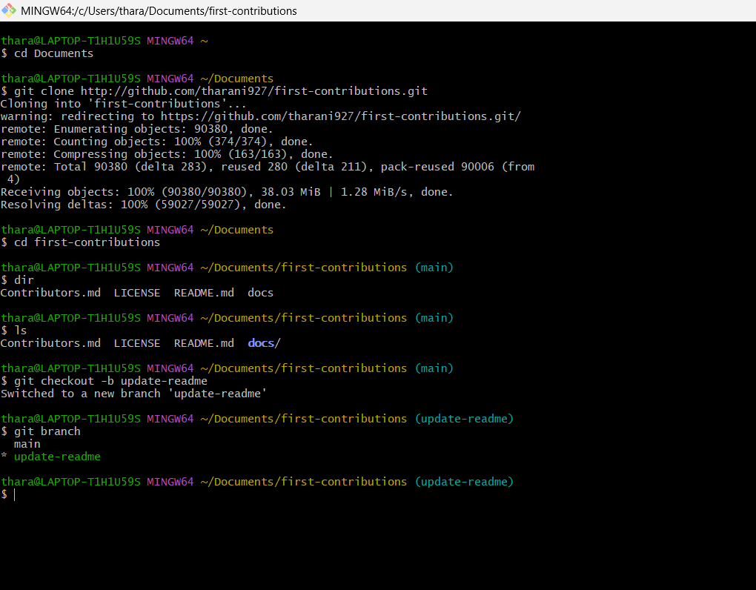
Step 4: Modify the Project
- Open the project in a code editor such as Visual Studio Code.
- Make the required changes, such as adding a new feature, fixing a bug, or updating the README file.
- Save all the modified files.
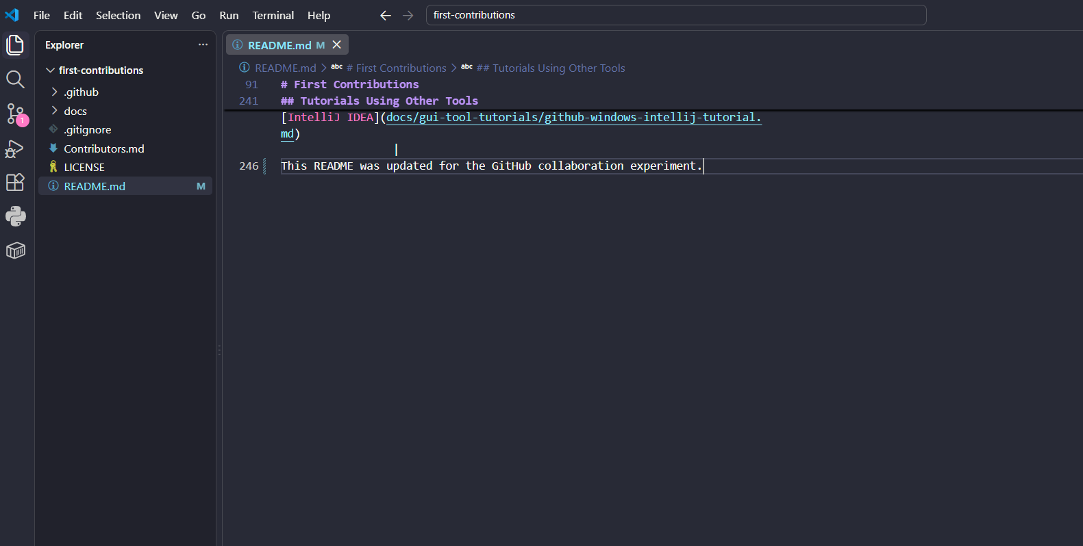
Step 5: Commit and Push the Changes
- Check the modified files using the git status command.
- Stage the changes using the git add command.
- Commit the changes with an appropriate commit message using the git commit command.
- Push the feature branch to the forked GitHub repository using the git push command.
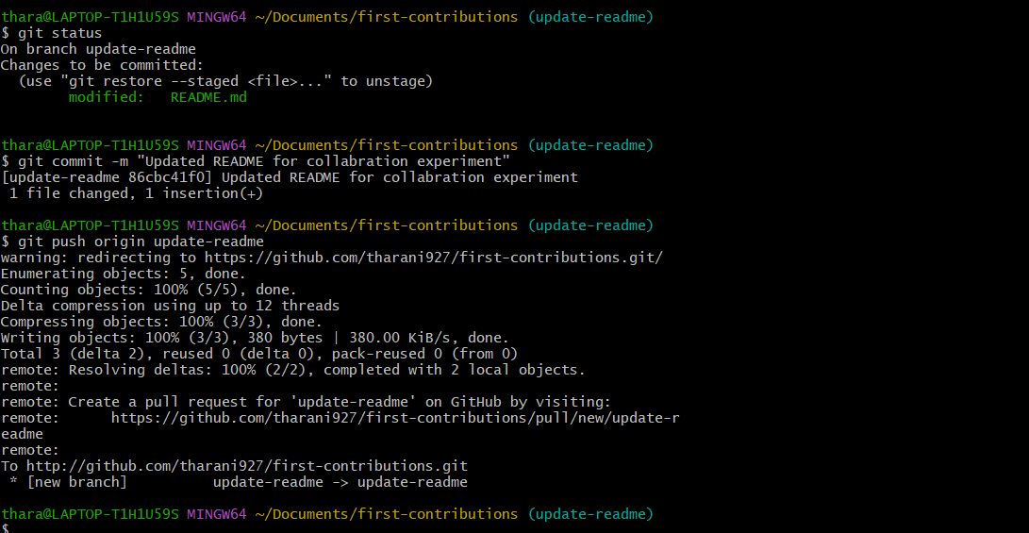
Step 6: Create a Pull Request
- Open the forked repository on GitHub.
- Click Compare & Pull Request or New Pull Request.
- Select the feature branch as the source and the main branch as the destination.
- Add a suitable title and description.
- Submit the pull request.
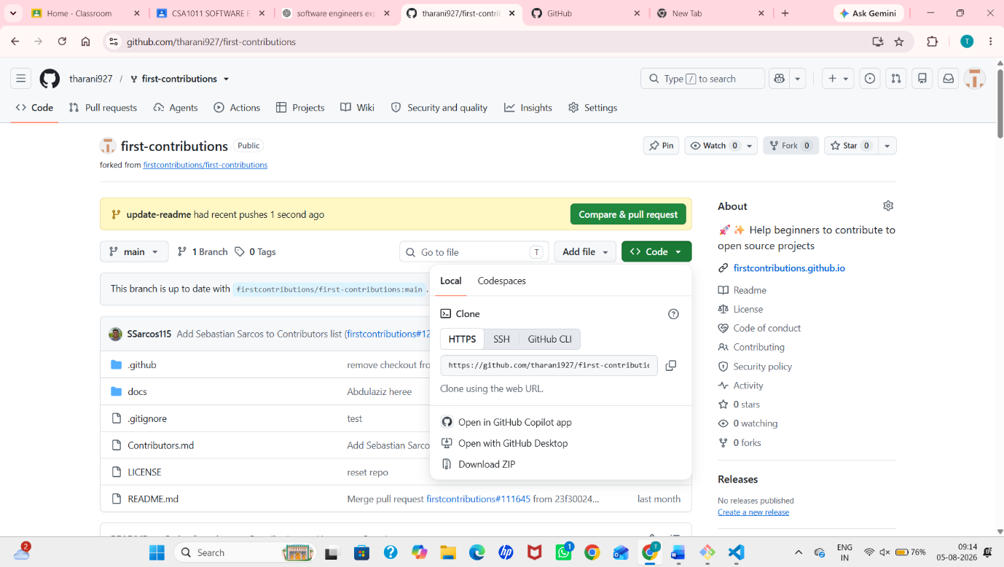
Step 7: Review the Pull Request
- Review the changes shown in the pull request.
- Verify the modified files and commit history.
- Add review comments or feedback if required.
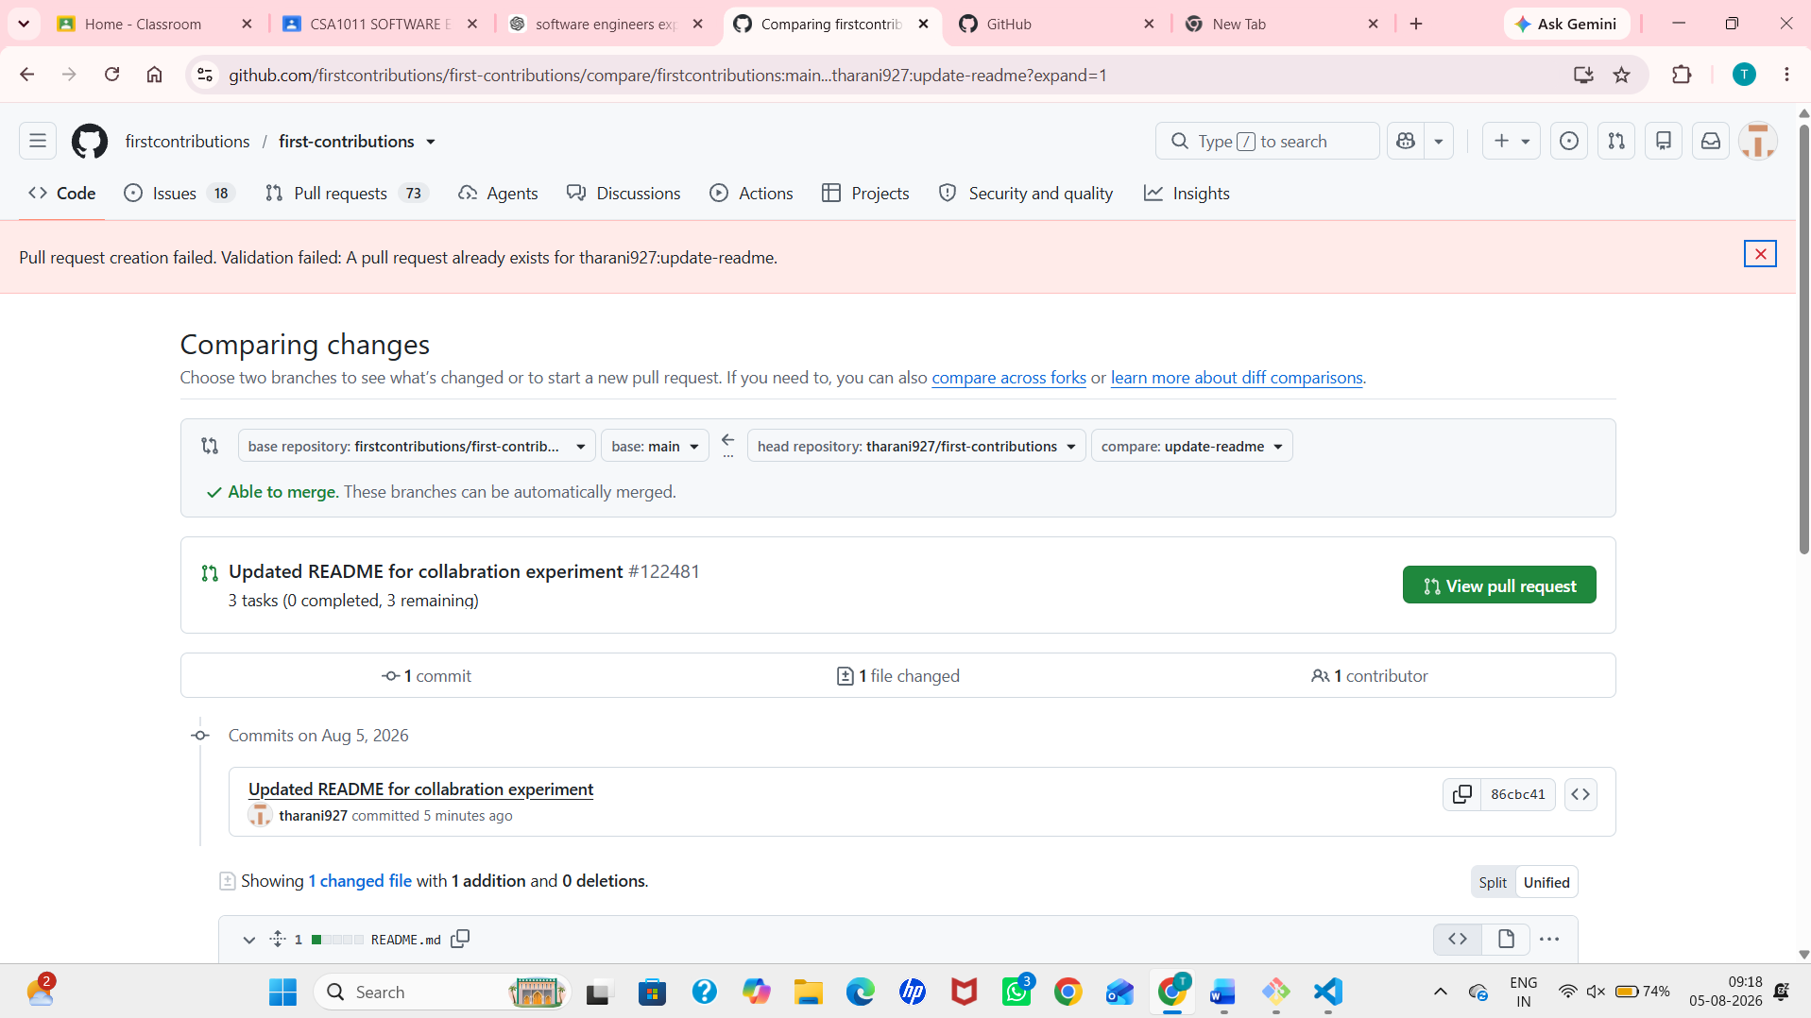
Step 8: Update the Pull Request
- Make additional modifications if feedback is received.
- Commit the updated changes.
- Push the latest commits to the same feature branch.
- Verify that the pull request is updated automatically.
Step 9: Merge the Pull Request
- After the pull request is approved, merge it into the main branch.
- Confirm that the changes have been successfully merged.
- Delete the feature branch if it is no longer required.
“You cannot merge this Pull Request because it targets the original repository (firstcontributions/first-contributions), and only the repository maintainers have permission to merge it.”
Step 10: Document the Work
- Copy the pull request URL.
- Prepare a brief summary of the changes made.
- Submit the pull request link along with the summary for evaluation.
- https://github.com/firstcontributions/first-contributions/pull/122481
